NT SCAFFOLDS PTY LTD
COMPANY CAPABILITY STATEMENT



Scaffold Hire & Sales
Labour
Transport Division
" A Scaffolding company owned and run by Scaffolders "

Vision and Values

At the heart of NT Scaffolds philosophy is our strong, value based culture that focuses less on what we do and more on how we do it. It's no surprise that our NT Scaffold vision and values are incredibly important to each and every one of us. Achieving sustainable growth through the quality of our people and the strength of our relationships.

Values

Safety: Safety and Health are what matters most.
Leadership: We take ownership and lead by example at all levels.
Training: NTS are committed to providing every employee with on-going training.
People: The people we have are the strength of our business.
Teamwork: We work together and support each other to achieve success.
Client Relationships: We have trusting relationship with our clients.
Community: We show respect for the community, Indigenous Australians and the environment.

" We create high performing teams that are aligned to our vision and values"

Shared Success

At NTS we strive for Shared Success. This is achieved by developing high performing teams that are aligned to our vision and values. Our business believes training is a two way process. We encourage employees to participate and to highlight any gaps in their own skills or knowledge they believe they have.

We know that if we succeed, then all our valued clients also succeed. This integrated approach begins with our people and the belief that together we can develop trusting relationships with all stakeholders to achieve long term mutual goals.

Commitment to Delivery

Recognised as a respected leader in our industry. NTS offers a diverse range of services to the
off shore/onshore Oil & Gas, Mining and construction sectors in Northern territory and overseas.

Established in 2005 NTS remarkable growth is underlined by 35 years experience delivering scaffold access solutions.

Our success is based on our ability to build strong relationships and produce positive outcomes for our clients.

Our capabilities cover all aspects of scaffolding which include scaffold hire, design, engineering, labour and transport logistics.

NTS is recognised as a one-stop-shop for all scaffold access needs.

With our own transport division, we operate and deliver services throughout the Northern Territory including regional and remote locations often with challenging logistics.

Expertise and Enterprise

We are committed to outstanding scaffold access and project management, regardless of the scale, time frame or the intricacy of the work.

Our partners in success include companies such as:

- Lend Lease Project Managers
- Hutchinson Builders
- Toga Construction
- John Holland Group
- Laing'O'Rourke
- ENI Australia
- Woodgroup
- Van Oord
- Boskalis
- Maersk Contractors
- Veolia Environmental Services Australia

NTS's reputation is founded on a culture of safety, people, leadership, client relationships, team work and community. These principles are firmly embedded in all our HR,WHS & QA management systems.

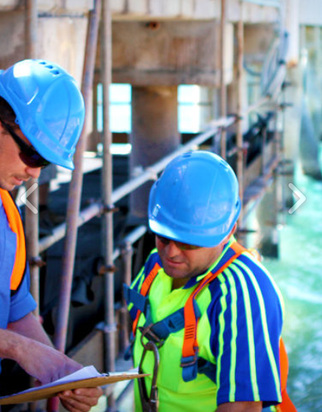

Construction
NTS has successfully delivered large scale construction projects to the commercial, industrial and government PFI/ hospital sectors.
For over ten years across the Northern Territory, often in remote and challenging locations, we have collaborated with clients to provide exceptional value in scaffold and access solutions for projects of all sizes and complexity.
"Responsive, competitive access solutions"

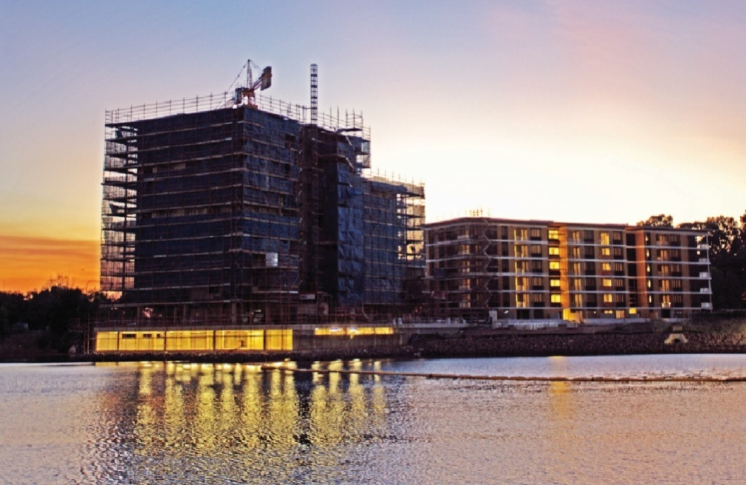

We work closely with our valued clients to achieve unique, innovative and cost effect scaffold access solutions. We pride ourselves on delivering outstanding results on time, on budget and with the highest degree of professionalism.
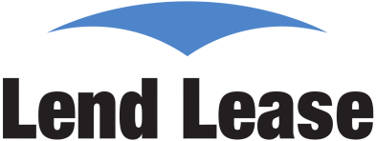

Defence
NTS has been involved in some of Darwins biggest Defense projects ranging from the recent Joint Logistics Unit, maintenance on the ACPB's to residential quarters for our defense personnel.
- Joint Logistics Unit (JLU) North, Robertson Barracks.
- 9 x 3 storey residential apartment blocks, Robertson Barracks.
- construction of Expolsives Store, RAAF Base Tindal.
- C17 construction, RAAF Base Darwin.
- Darwin RAAF Radar, Annual maintenance, Raytheon Australia
- Many Armidale Class Patrol Boats, Submarines and Customs Vessels during maintenance and repairs, Coonawarra Naval Base Larrakeyah.
- refurbishment of the existing heritage quarters and the residential buildings, Coonawarra Naval Base Larrakeyah.
- Shoal Bay, Maintenance

Clearance for work has never been an issue and we have had zero security breaches.



Off shore/onshore Oil/Gas, Mining
Since 2005 NTS has been delivering complex scaffold solutions for projects and clients in the mining, oil/gas sector.
Our projects range from
- designing and constructing a suspended scaffold over the side of a heli-deck on an oil rig.
- engineered load bearing scaffold to support a 22 tonne crane boom during a repair on an oil rig.
- underside of oil rigs.
- underside of wharves and bridges.
- cantilevered and swing stage scaffolds.
At NTS we enjoy long standing and respected relationship with numerous major mining and energy companies. We have links to many of the major resource projects here in the Northern Territory and have a strong client focus, understanding the priorities and drivers of clients in these sectors.

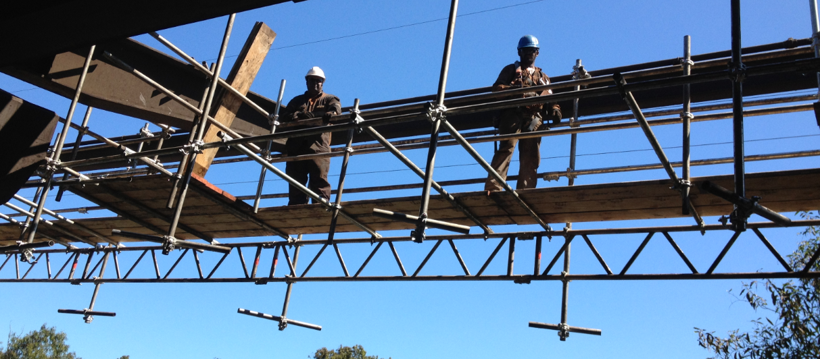

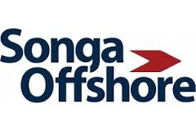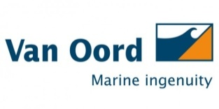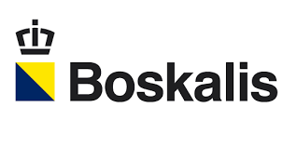
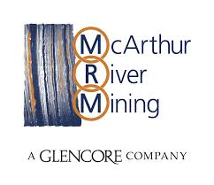

Scaffold Hire & Sales
NTS source and import scaffold systems locally and internationally.
Our in house stock consists of:
- Kwik Stage modular system
- Cuplock modular system
- Tube and Coupler
- Aluminium Mobile Scaffold
- GEDA Material Hoists

Relationships
Our focus at NTS has always been on building long term relationships with our valued clients.
From our beginnings, we have worked to establish and strengthen our relationships. We are proud that over time, these have developed through mutual trust, expertise and our proven success.

As a result NTS enjoys positive, worthwhile and long standing relationships with our clients in the mining, oil & gas sector. We understand the needs and drivers of clients and delivery of their expectations.

Because we are pro-active, solution focused and active listeners, we firmly believe our clients find us easy to work with, and enjoy collaborating on successful projects.

People

When it comes to NTS real strength, it's our people who make this business. They are the clear and leading reasons for our ongoing success.

Our NTS recruitment strategy is to attach, retain and develop the right people. Through a strong alliance with (IAS) Indigenous Access Services we recruit and train members of indigenous communities throughout the Northern Territory.

NTS office is located in Winnellie, Darwin making us extremely well placed to deliver projects across the NT and internationally. With local based work force of 50 employee's and a data base of 200, our labour management is second to none.

Safety

Keeping our people and our projects safe is central to everything we do at NTS. Our dedicated safety and quality management procedures is designed to empower every person in the organisation to ensure their work practices are focussed on zero harm.

NTS has engaged HSEMA fulltime as a project based third party safety consultant to achieve, audit and maintain our zero harm policy.

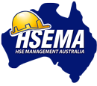

NTS in the community

As well as providing local employment and training opportunities, we support a range of ongoing initiatives that help create healthy, vibrant and cohesive communities.

We believe the best way that NTS can make meaningful contributions to the community is through engagement. We do this in a number of ways, such as charity events, creating awareness, sponsorship, volunteering and donations.

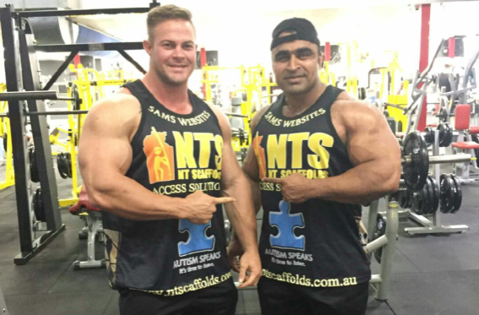

Testaments

'NT Scaffolds are our preferred provider for offshore operations. They have constructed numerous scaffolds, under difficult and trying conditions to an approved offshore standard with a high degree of professionalism and work quality. Examples include a suspended scaffold over the side of our heli-deck and a fully engineered load bearing scaffold to support a 22 tonne crane boom during a repair'.

'I have found their quoting system reliable and simple and their pricing is always fair. NT Scaffolds deliver on their word at a reasonable price'.

Chris Donnelly
Superintendant
Maersk Contractors Australia

'NT Scaffolds is a vital link in our support chain, providing a 24/7 support service to our clients. Every time we call upon NT Scaffolds they are always willing to assist providing a punctual and professional service. Wood Group has nothing but praise for NT Scaffolds'

Chris Wooley
Operations Manager
Wood Group Production Facilities, Darwin

Contact & Location

- phone: 08 8947 5592
- web: www.ntscaffolds.com.au
- email: info@ntscaffold.com.au
- location:16 Sadgroves Cres, Winnellie, NT 0821

